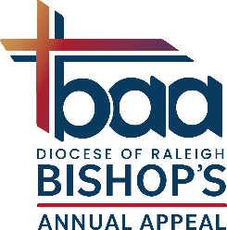
Name of Grant: Diocese of Raleigh Respect Life Grant Funded by:

Send Deacon Joshua Klickman
Application to: 7200 Stonehenge Dr.
Raleigh, NC 27613-1620
E-mail: Joshua.Klickman@raldioc.org,
FAX: (984) 900-3181 C: 919.632.7379

Decision Makers | Diocesan Human Life and Dignity (HLD) Grant Review Committee
Purpose | These Funds are intended to proclaim that human life is a precious gift from God; that each person who receives this gift has responsibilities toward God, self, and others; and that society, through its laws and social institutions, must protect and nurture human life at every stage of its existence.
Funding Source | Funds are derived from a grant provided by the Diocese of Raleigh generated by Bishop Annual Appeal funds. Amount available $20,000.
Intended use and Restrictions | - The intention of the grant is to distribute resources of the Church of Raleigh to promote respect for life in the four pillars, as per the USCCB’s Pastoral Plan for Pro-Life Activity.  - Public Information and Education - to deepen understanding of the sanctity of human life and the mission of the Church to witness and serve all human life.  - Pastoral Care - for women, and anyone affected by abortion; for the disabled, sick, and dying, and their families and caregivers; for those who have lost loved ones to violent crime; and for ministry to those in prison, especially who are sentenced to death.  - Public Policy - efforts directed to restoring the legal protection of preborn children and those vulnerable to pressures to end their lives by assisted suicide, and to provide morally acceptable alternatives to practices that threaten life including abortion & assisted suicide.  - Prayer and Worship - directed to participation in the sacramental life of the Church and in programs of communal and individual prayer; spiritual works that recognize that the culture of death that surrounds us today must be replaced by love and a culture of life.  - The funds are intended for projects to assist with growth, NOT for operational costs. Applications that propose to increase fundraising capability, expansion (e.g. “seed money” for new projects and incremental improvements), will be prioritized.  - New applications will be prioritized. Organizations may receive grants for a particular project for no more than three consecutive years. A grantee report must be submitted for organizations who have received grants in previous years to show use of funds.
Brief History | Established in 2000 to meet the demand for Respect Life initiatives.
Grants Range | $500 to $3,000
Contact Person(s) | Deacon Joshua Klickman, (M) 919.632.7379, E-mail: Joshua.Klickman@raldioc.org *
Application Guidelines | Applications are available April 1. Deadline to submit applications is June 1, those received after the deadline will not be considered. Grantee is responsible to obtain the endorsement of the local Pastor of the Catholic Church in their community (see page 4). Grants are awarded at a luncheon in October. A copy of proof of tax-exempt status under Section 501(c)(3) of the IRS Code must be submitted, no project will be funded unless it has 501(C)(3) status. First time applicants must submit a W9.
Ways to Apply | There are three ways to submit your application, email (preferred), paper copy (mailed to the address above,) or by fax. Confirm receipt via email from the Contact Person.

* Direct all questions or inquiries regarding grant eligibility to the contact person.
Respect Life Grant
OFFICIAL GRANT APPLICATION FORM
(ONLY APPLICATIONS SUBMITTED ON THIS FORM WILL BE ACCEPTED FOR CONSIDERATION)
- Deanery in which applicant resides: Indicate the Catholic Diocese of Raleigh Deanery where project is located (Check One)

☐ Albemarle ☐ Cape Fear ☐ Fayetteville ☐ New Bern ☐ Newton Grove
☐ Tar River ☐ Raleigh ☐ Piedmont

- Name of organization requesting funds as it appears on W9

Address

City State

Phone Fax

- Grant Manager/Contact Person

Title Phone

Email Address

- Amount Requested: $

- Catholic Moral and Social Teaching

  - All grantees must agree they will not engage in activities in conflict with fundamental Catholic moral and social teaching.
  - All grantees must agree they will not engage in prohibited political campaign intervention on behalf of or in opposition to any candidate for political office within the meaning of section 501(c)(3).
Name and Signature:

Position:

- Describe the need or concern you are seeking to address in the community. Include the following:
  - The approximate number of people served
  - The profile of the persons/community you are serving
  - The approach/strategy used to address this need.

- What is the specific project of your program that you are asking the Respect Life Grant to fund?

- How does this program promote or support the four pillars as per the USCCB’s Pastoral Plan for Pro-Life Activity? How do the beneficiaries of your program have a voice in the project?

- Provide an itemized list of the use of Respect Life Grant funds for this project.
Item | Cost
Total Cost

- Is there any Catholic parish/group participation (association) in this project? Yes No
If yes, please name the parish/group and indicate how they are involved:

- How has your organization (or the Catholic associate) promoted the Bishop’s Annual Appeal (BAA), and/or what are your/their plans to promote the BAA?

- Have you received funding from the Respect Life Grant or any other grant from the Catholic Church? If so, when?

- Endorsements
Please name two references other than staff or Board members.
Name: Name
Address Address
Email Email
Phone (W) Phone (W)
Phone (M) Phone (M)

- Does your organization have an annual independent audit? (Initial)

- Attach the following:
  - A copy of proof of tax-exempt status under Section 501(c)3 of the IRS Code. No project will be funded unless it has 501c (3) status
  - Mission Statement of your organization
  - First time applicants must submit a W9

- Notice: If funding is approved, a Grantee Report on the use of the funds is required within nine months of receipt of funds and attached to future RL/CCHD grant application. If not received, future funding requests will be denied. Initial as read and understood:

- Preparer’s printed name and signature

Preparer’s Email Address Telephone

Date of Application

Checklist
1. Is your evaluation form for last year’s grant submitted? (For those who received a grant)
2. Have you completed the Catholic pastor’s endorsement page? (Page 5)
3. Have you initialed #14 and signed block #15?
4. Have you included your mission statement?
_____5. Have you included your W9?(first time applicants, ask contact person on page 1 if unsure)
_____6. Have you included a slide of your proposal?
_____7. Have you included a slide of your previous project (if awarded HLD grant in the past)?

Endorsement of Application by Local Catholic Pastor

Grant Applicant – Please contact the Catholic Church pastor nearest to your area of service. Speak to him about the project and have the form below completed. For assistance locating a pastor, please refer to the contact person on Page 1.

Pastor/Pastoral Administrator – The Diocese asks that local pastors come to know the projects that are funded by the Respect Life Grant in their area. Respect Life Grants are intended to support projects that proclaim that human life is a precious gift from God; that each person who receives this gift has responsibilities toward God, self, and others; and that society, through its laws and social institutions, must protect and nurture human life at every stage of its existence. Thank you for your interest.

Pastor/Pastoral Administrator’s Printed Name Signature Date

Pastor Email Address Pastor Phone Number

Parish, City

Please select one…

I endorse this request because

I do not endorse this request because

Financial Addendum Required for all Diocesan Grant Applications
(For Catholic Organizations)

Category | Parish Financial Information | School Financial Information  (if applying for school)
# of Registered Households |  |  | # of Students
Total Annual Offertory for most recently completed fiscal year. | $ | $ | Total Tuition
Total Annual Income for  most recently completed fiscal year. | $ | $ | Amount Contributed by Parish
 | $ | $ | Total Other Income
 | $ | $ | Total All Income

List Amounts Deposited in the Following Accounts

 | Checking Accounts | Checking Accounts
General Checking Account | $ | $ | General Checking Account
Restricted Checking Account | List Purpose & Amount | List Purpose & Amount | Restricted Checking Account
Purpose | $ | $ | Purpose
Purpose | $ | $ | Purpose
Purpose | $ | $ | Purpose
Purpose | $ | $ | Purpose
 | Savings Accounts | Savings Accounts
General Savings Account | $ | $ | General Savings Account
Restricted Savings Accounts | List Purpose & Amount | List Purpose & Amount | Restricted Savings Account
Building | $ | $ | Building
GWOC | $ | $ | Purpose
Purpose | $ | $ | Purpose
Purpose | $ | $ | Purpose
Purpose | $ | $ | Purpose

Financial Addendum Required for all Diocesan Grant Applications
(For non-Catholic Organizations)

Budget
Expenses
Income
Funds Received from Grants
Total Income

General Checking Accounts – List Amounts on Deposit
Amount | Purpose

Restricted Checking Accounts – List Amounts on Deposit
Amount | Purpose

General Savings Accounts – List Amounts on Deposit
Amount | Purpose

Restricted Savings Accounts – List Amounts on Deposit
Amount | Purpose

Template for “slide of proposal” see website for powerpoint template file
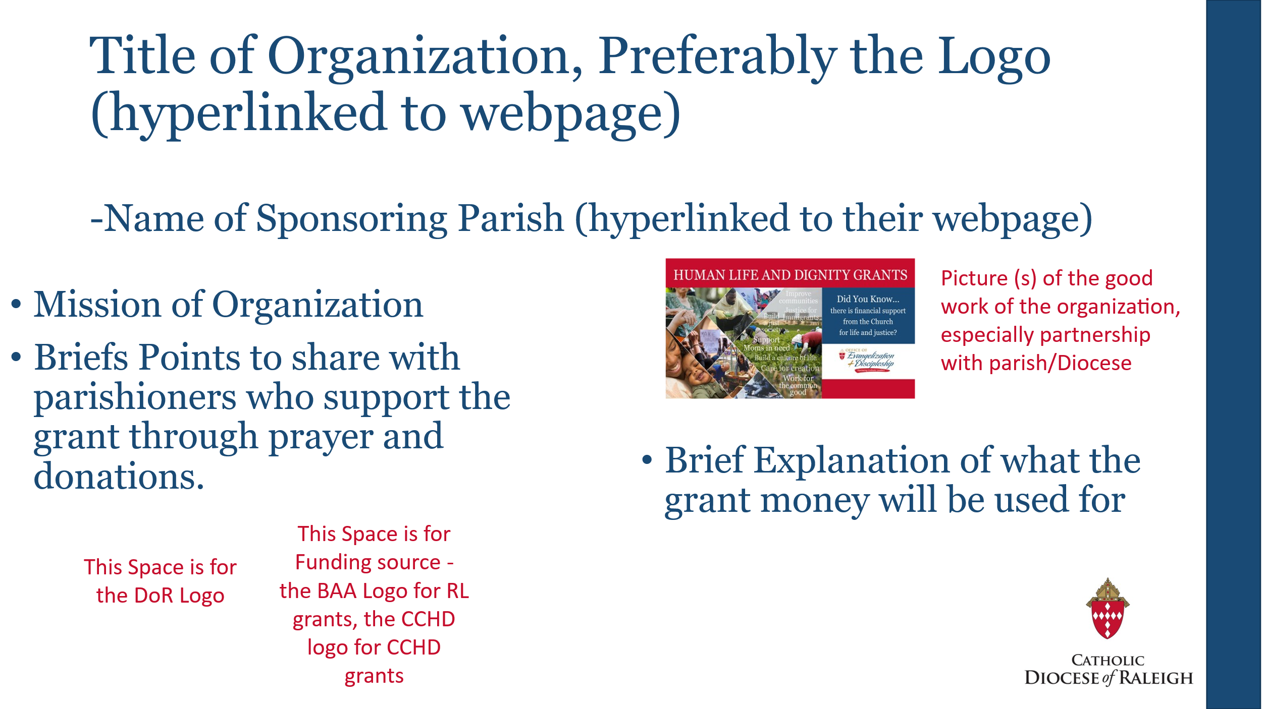
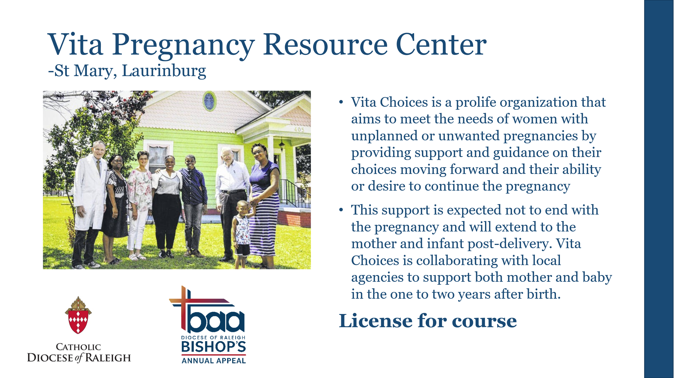
Examples of slide for proposal, use similar method for grant report
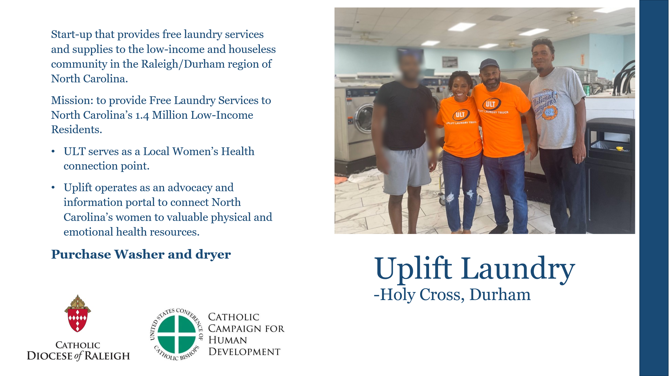

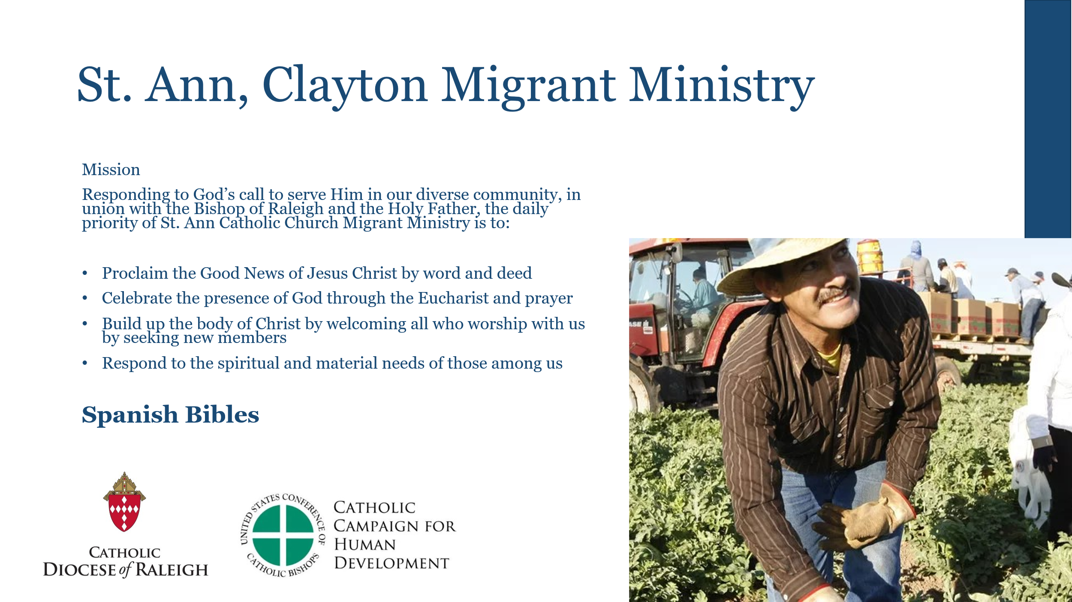
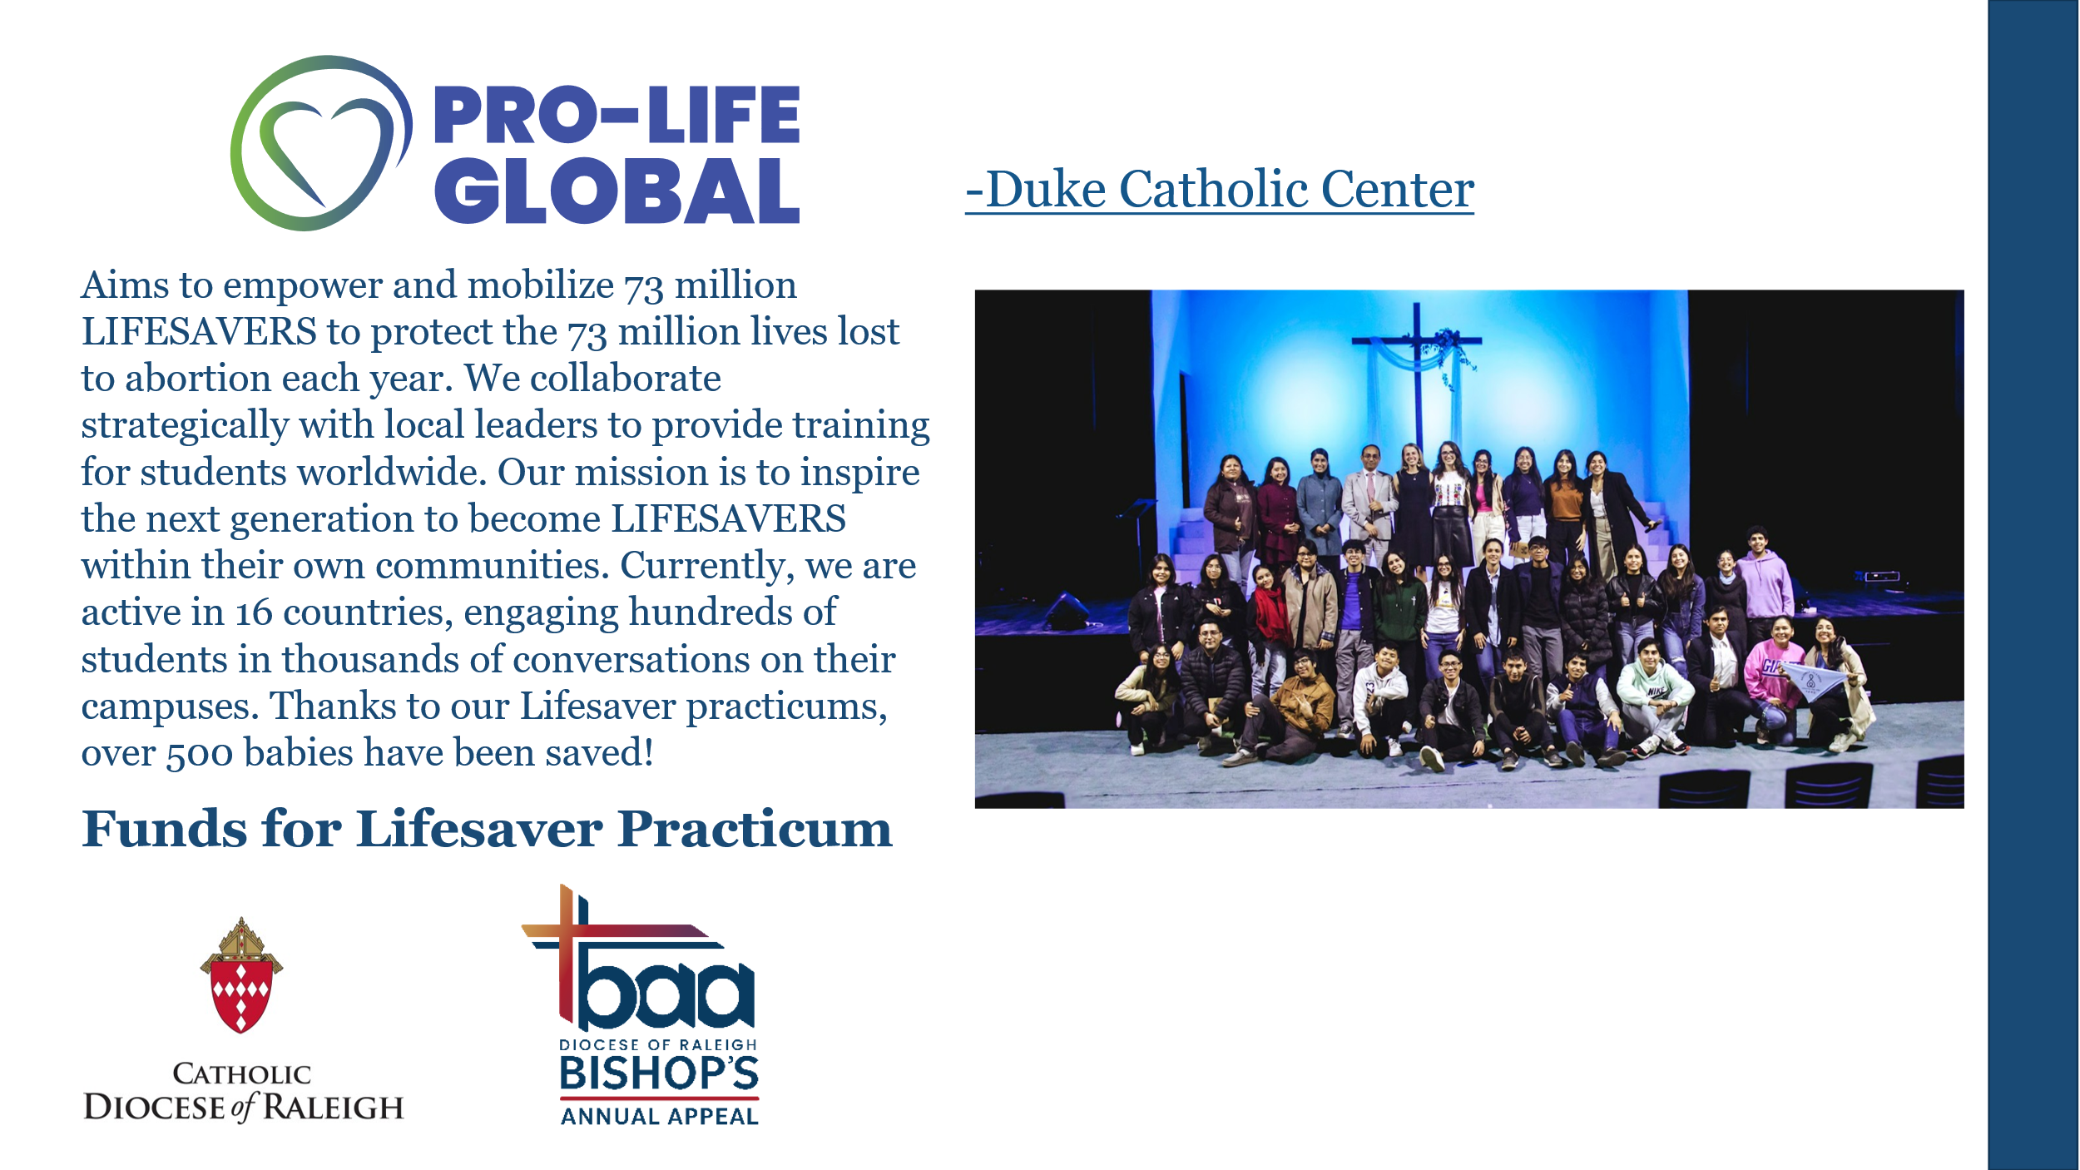

Grant Report should include a single slide to show board how money was used, include name of project, name of organization, name of associated Churches, pictures, and explanation of funds used (either in line or as spreadsheet
Example

