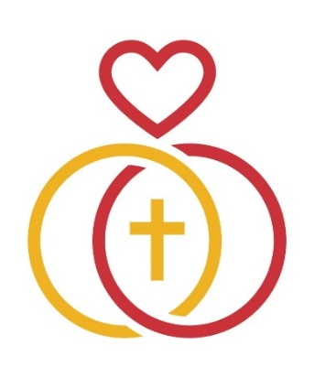
EVENT PRESS RELEASE

RELEASE DATE:
April 5, 2025
EVENT DATE:
June 14, 2025
FOR IMMEDIATE RELEASE
Worldwide Marriage Encounter Hosts “God Chose You for Me”, a Catholic Marital Retreat

[New Bern, North Carolina] – Worldwide Marriage Encounter (WWME) is proud to announce a transformative seven-hour experience titled “God Chose You for Me.” The retreat is designed to help married couples deepen their spiritual connection and develop a personalized couple prayer by exploring the divine aspects of their union.

The “God Chose You for Me” retreat is being offered for the first time ever in the southeast United States. It will be held on June 14, 2025, from 9:00 AM to 4:00 PM eastern time at Saint Paul Parsh, 3005 Country Club Road, New Bern, NC 28562. The cost is $100 per couple until May 14, 2025, and $125 thereafter.

The “God Chose You for Me” retreat is led by a team consisting of a priest or deacon, a married couple, and a surviving spouse. They will share their personal experiences of building strong spiritual foundations within their own marriages and their work with other couples.

The retreat begins with the exploration of matrimonial spirituality, rooted in the love shared between husband and wife as a reflection of God’s presence. Participants will examine how their marital vows reveal God’s love for all His children and how the Sacrament of Matrimony bestows special graces upon each couple and that of the entire church.

“Once you have said ‘yes’ to the Sacrament of Matrimony, the primary way God calls you to Him is through your married relationship,” Father Larry Brault, the priest who co-authored the event.

Throughout the retreat, couples will be guided in creating a personal couple prayer developed progressively after each chapter of reflection. This prayer will serve as a daily spiritual practice, reinforcing their commitment and spiritual bond.

Previous participants of WWME’s retreats, Bob and Melinda said: “It’s an experience of why you married in the first place and how you have grown in your love with God in the center.”

“God Chose You for Me” is a journey of reflections deepened by the Sacrament of Matrimony. This experience helps couples mature in their love and culminate a commitment that brings holiness into their lives.

Worldwide Marriage Encounter (WWME), established in 1968, is the original faith-based marriage enrichment program. WWME has transformed the lives of countless married couples and priests through its peer-to-peer experiences. WWME presents 2,000 experiences in nearly 100 countries, with over 1,600 presenting teams in North America offering programs in English, Spanish, French, Korean, and soon in Portuguese as well. The mission of WWME is to highlight the value of marriage and holy orders within the Church and in the broader community.

For more information and to apply for the “God Chose You for Me” event, please visit wwme.org or contact [contact information].
###

