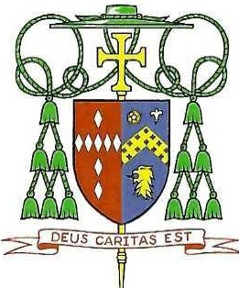
DIOCESE OF RALEIGH Office of the Bishop

Easter 2026

Dear Brothers and Sisters in Christ,

At Easter, our churches will be transformed with bells and songs and light and incense. But let us be reminded that what truly needs to be transformed is us. We need to experience what we celebrate.

When Jesus descended from heaven, taking on our human nature, He entered a world much like ours today-one gripped by power struggles, enslavement to sin, where human dignity is measured only by what is produced or possessed. He did not avoid or indulge this brokenness. Instead, He embraced our human history fully, not to conform to it, but to redeem and transform it through His divine plan.
The power behind His plan is quite simple, but also quite different from what our world considers "powerful." Jesus shows us a different way- onewhere love, mercy, service and vulnerability become transformative powers through Him. The original pain and humility of the cross become a healing medicine that eradicates sin and destructive forces and restores to us the beauty of our God-given dignity.
This is the triumph we proclaim on Easter Sunday: life over death, love over sin, freedom over slavery. Alleluia! Jesus is risen!

Easter invites us to enter into this conversion with Him. In moments of fragility-whether personal trials, global challenges, or even times of isolation-we are reminded how little control we truly have.
Technology grants us immense power, yet it cannot conquer death or heal the heart. God challenges us to prioritize love over control, to see ourselves and others as he sees. He loves us not in spite of our weaknesses, wounds, fears, and failings, but because of them-revealing our true greatness as His beloved children.

We must acknowledge the difficult truth that many of the problems and challenges of our world are a reflection of our own sins. Let us use this time of tremendous grace to hear and to share the Good News that the world so desperately needs. Let us celebrate this joyful time with renewed faith, embracing His power and believing that when we surrender control to His ways, we become truly free.

We are not merely spectators in this great transformation; God wants us to be transformed by Him and to celebrate who we are through Him. May this Easter be more than a joyful moment, but the beginning of a transformed reality where God's beauty and love reshape each of our lives.

In Christ,

