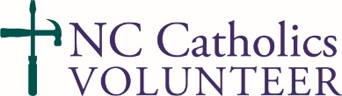
New Dates Scheduled! Join NC Catholics Volunteer on the following dates: March 9th (Fayetteville Deanery); May 18th (Fayetteville Deanery); June 22nd (Tar River Deanery). Help as we repair homes damaged by Hurricane Matthew and Hurricane Florence in Edgecombe County and Cumberland County. Volunteers from all areas and of all experience levels are encouraged to participate!
If you have any questions, please contact Daniel Altenau at Daniel.Altenau@raldioc.org or at (919) 821 - 9767. Spots are limited so sign up now! www.CatholicCharitiesRaleigh.org/NCCV

