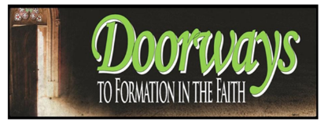

Basic Doorways Course Registration Form

Course Information

Basic Courses: | Catechetical Methods and Skills | The Creed | Introduction to  Scripture | Introduction to Christian Morality | Introduction to Sacraments | Introduction to  Liturgy | Introduction to Christian Prayer

Course Facilitator
 | First Name | Last Name
Course Dates:

Course Location
 | Name of Parish or School | City

Participant Information
Participant
 | First Name | Last Name

Participant Address
 | Address | Apt. #

 | City | State | Zip Code
E-mail Address: |  | Phone Number:

Parish Name: |  | Parish City:

Payment

Registration fee is the parish discretion

Last updated: 10/25/2018

